In Lab

Name: Muhammad Kaleem Ullah Reg No.: FA19-BCE-007

1. **In-Lab Tasks**

**5.1** Write templates for the two functions minimum and maximum. The minimum function should accept two arguments and return the value of the argument that is the lesser of the two. The maximum function should accept two arguments and return the value of the argument that is the greater of the two. Design a simple program that demonstrates the templates with data types int, char, float and strings.

**Solution:**

* **Code:**

#include<iostream>

using namespace std;

template <class type>

type minimum(type n1,type n2)

{

if(n1>n2)

{

return n2;

}

else

{

return n1;

}

}

template <class type>

type maximum(type n1,type n2)

{

if(n1<n2)

{

return n2;

}

else

{

return n1;

}

}

int main()

{

cout<<"minimum value : "<<minimum(3,2);

cout<<endl<<"Maximum value : "<<maximum(3,2);

cout<<endl<<"Character input : "<<minimum('c','d');

cout<<endl<<"floating input : "<<maximum(4.5,3.5);

cout<<endl<<"string input : "<<minimum("kaleem","ullah");

cout<<endl<<"string maximum : "<<maximum("kaleem ","ullah");

return 0;

}

* **Output:**

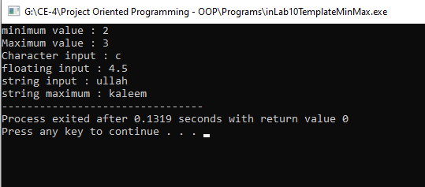

**5.2** Write a template for a function called total. The function should keep a running total of values entered by the user, then return the total. The argument sent into the function should be the number of values the function is to read. Test the template in a simple driver program that sends values of various types as arguments and displays the results.

**Solution:**

* **Code:**

#include <iostream>

using namespace std;

template <typename T>

T total(int n, T value)

{

T total;

cin >> value;

total = value;

for(int i = 1; i < n; i++)

{

cin >> value;

total += value;

}

return total;

}

int main()

{

int num;

cout << "How many values you want to enter .... "; cin >> num;

int t1 = total(num, 1);

cout << "Total = " << t1 << endl;

double t2 = total(num, 1.0);

cout << "The total is: " << t2 << endl;

}

* **Output:**

